**Week 7-13.React JS-HOL**

**Name-Adi Jain**

**Superset ID- 6390400**

**Hands on**

Create a React App named “bloggerapp” in with 3 components.

1. Book Details
2. Blog Details
3. Course Details

Implement this with as many ways possible of Conditional Rendering.

**Code**

**File Name: index.js**

import React from 'react';

import ReactDOM from 'react-dom/client';

import './index.css';

import App from './App';

import reportWebVitals from './reportWebVitals';

const root = ReactDOM.createRoot(document.getElementById('root'));

root.render(

  <React.StrictMode>

    <App />

  </React.StrictMode>

);

reportWebVitals();

**========================================================**

**File Name: BookDetails.js**

function BookDetails() {

    return <div><h2>📚 Book Details</h2><p>This is the book section.</p></div>;

  }

  export default BookDetails;

**========================================================**

**File Name: BlogDetails.js**

function BlogDetails() {

    return <div><h2>📝 Blog Details</h2><p>This is the blog section.</p></div>;

  }

  export default BlogDetails;

**========================================================**

**File Name: CourseDetails.js**

function CourseDetails() {

    return <div><h2>🎓 Course Details</h2><p>This is the course section.</p></div>;

  }

  export default CourseDetails;

**========================================================**

**File Name: App.js**

import { useState } from "react";

import BookDetails from "./components/BookDetails";

import BlogDetails from "./components/BlogDetails";

import CourseDetails from "./components/CourseDetails";

function App() {

  const [selected, setSelected] = useState("book");

  return (

    <div className="App">

      <h1>📖 BloggerApp Dashboard</h1>

      <div style={{ marginBottom: "20px" }}>

        <button onClick={() => setSelected("book")}>Book</button>

        <button onClick={() => setSelected("blog")}>Blog</button>

        <button onClick={() => setSelected("course")}>Course</button>

      </div>

      {/* Method 1: If-Else */}

      {selected === "book" && <BookDetails />}

      {selected === "blog" && <BlogDetails />}

      {selected === "course" && <CourseDetails />}

    </div>

  );

}

export default App;

**========================================================**

**Output**

**Folder Structure**

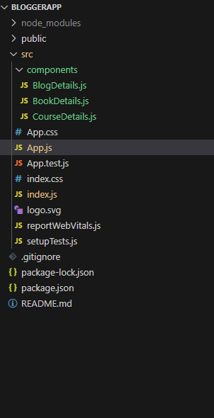

**========================================================**

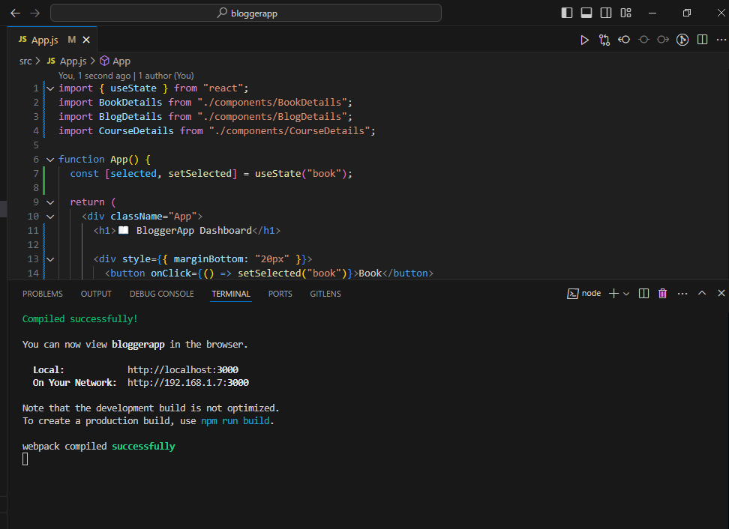

**========================================================**

**Book Details**

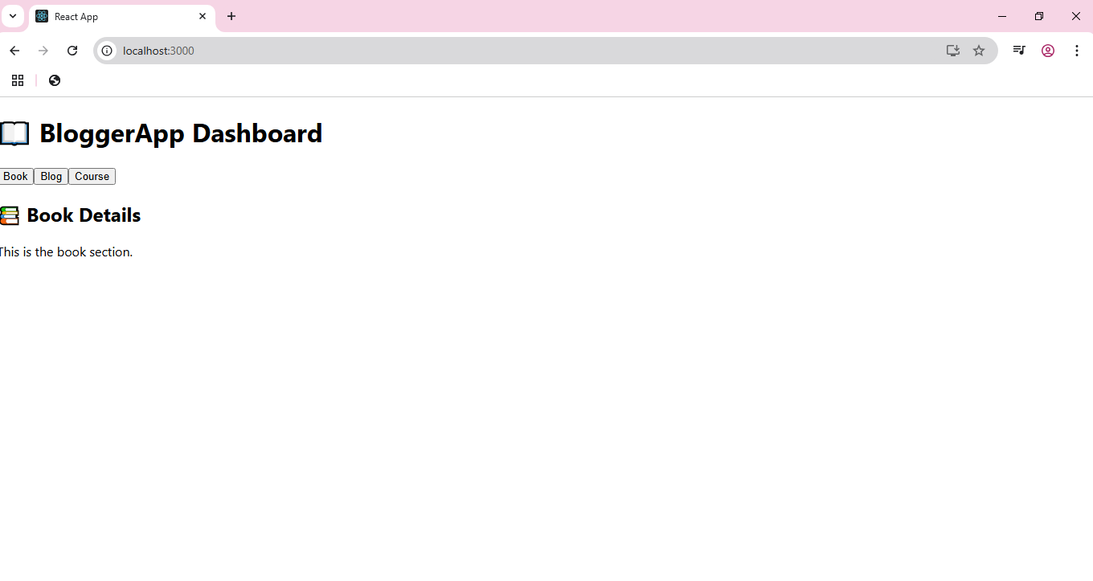

**========================================================**

**Blog Details**

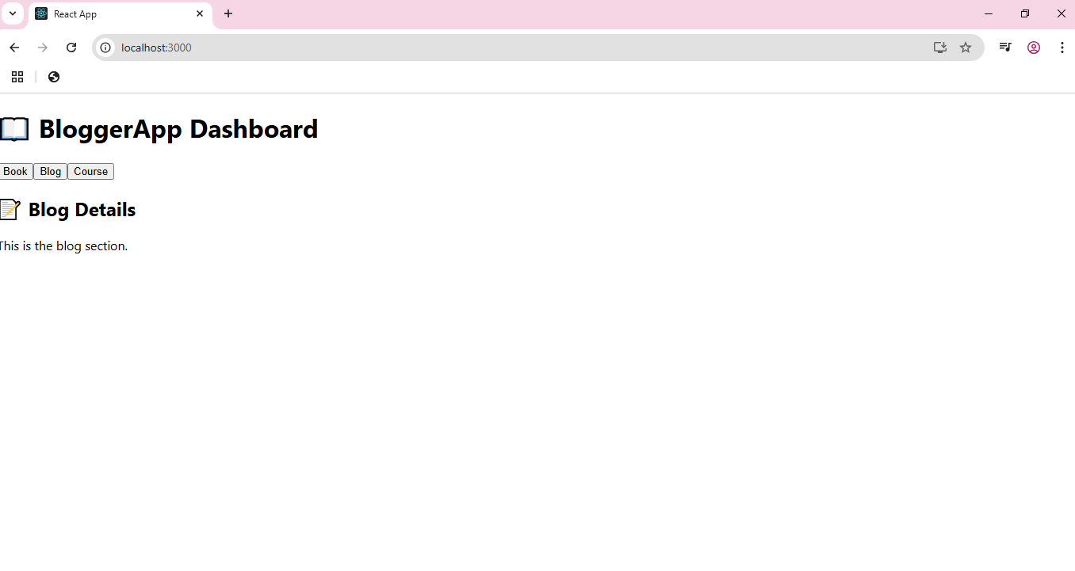

**========================================================**

**Course Details**



